|  |
| --- |
| SpiceJet– My Info Module(PMI) Live Project |
| **Project Functional Requirement Specification Version 1.0** |
|  |
| **Prepared by: Bala Murali Yalla**  **Reviewed by: Raghavendra BN** |
|  |

|  |
| --- |
|  |

# Contents:

1. Purpose of the document .................................................................................3

2. Project Overview ...............................................................................................3

2.1 Audience .......................................................................................................3

2.2 Hardware and Hosting ..................................................................................3

3. Information Architecture ...................................................................................4

3.1 Registration Page ..........................................................................................4

3.2 Login Page .....................................................................................................5

3.3 offers .............................................................................................................7

3.4 Booking Tickets (Reservation) .......................................................................8

3.4.1 Choosing a Departure Flight ...................................................................8

3.4.2 Traveller Details ......................................................................................9

3.4.3 Add On’s .................................................................................................9

3.4.4 Seat Assignment ....................................................................................10

3.5 Add Payment details/ Bank Details ..............................................................10

3.5.1 Payment Confirmation ..........................................................................11

3.5.2 Confirmation Summary .........................................................................12

3.6 Cancellation page ........................................................................................12

3.7 Logout Page .................................................................................................13

4. Sign-Off Document ...........................................................................................14

# Purpose of the document:

This is not a [www.spicejet.com](http://www.spicejet.com/) project plan. This is a guide to prebook flight tickets and hotel tickets

This document is divided into three sections:

• Project Overview

• Information Architecture

• Site Design

# Project Overview:

## 2.1 Audience:

[www.spicejet.com](http://www.spicejet.com/) mission is to become India's preferred low cost airline, delivering the lowest air fare with the highest consumer value, to price sensitive to customers. [www.spicejet.com](http://www.spicejet.com)  hopes to fulfil everyone's dream of flying! With India s economic and business growth, the percentage of travelling population is burgeoning. More and more Indians are travelling for both business and pleasure and everyone need to save both time and money. [www.spicejet.com](http://www.spicejet.com) vision is to address that and ensure that flying is for everyone. By using this guide you will learn how to use [www.spicejet.com](http://www.spicejet.com/) through the elements of graphical user interface and what's behind some of the advanced features that are not always obvious at first sight. [www.spicejet.com](http://www.spicejet.com/) will hopefully guide you around some common problems that frequently appear for users of [www.spicejet.com](http://www.spicejet.com/).

## 

## 2.2 Hardware and Hosting:

SpiceJet’s servers will be hosted at X company’s site.

SpiceJet will be hosted on two servers: One to host the actual website and (language) code, and the other to host the (database name)database.

# Information Architecture

Log in to the SpiceJet using your user account that has been created by the SpiceClub as shown in Figure

**3.1 Registration:**

This module provides about the information how to book tickets on flights, hotels near by the places, flight running status, special offers that the web page is providing, process of cancellation of a booked ticket by using an internet connected PC.

The user can access all the services provided by the SpiceJet web page is only by having an account in this web page. This is a complete guide to book tickets, hotels, to avail offers provided by the SpiceJet web page and also to cancel tickets

To enjoy the services that are provided by the SPICE JET first the individual should become the spice club member. So one should sign up in the SPICE JET web page.

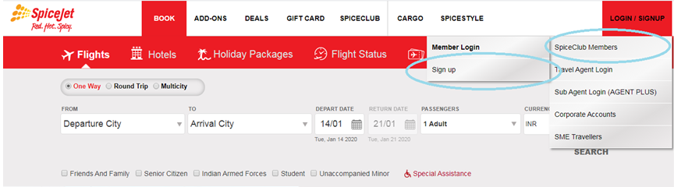

After clicking on the sign up then it is redirected to the below page. Fill all the above mandatory details of yourself and check in the check box and click on submit.

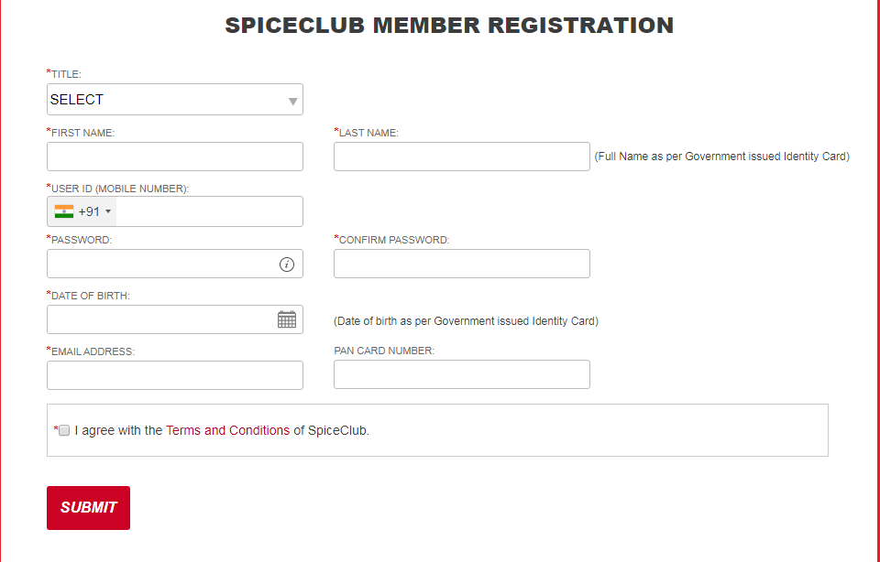

After clicking on submit you will receive an one time password(OTP) to your registered mobile number that you have given during the registration process. After confirming the below page you will get your account activated. And you can enjoy the services that are provided by the SPICE JET web page.

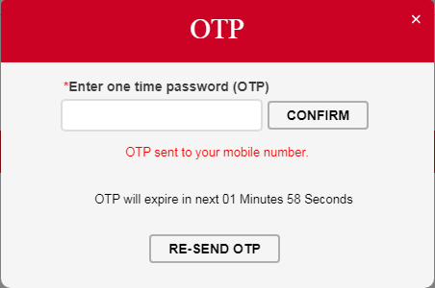

**3.2 Login page:**

Log in to the SpiceJet web page using your user account that has been created by the individual as shown in

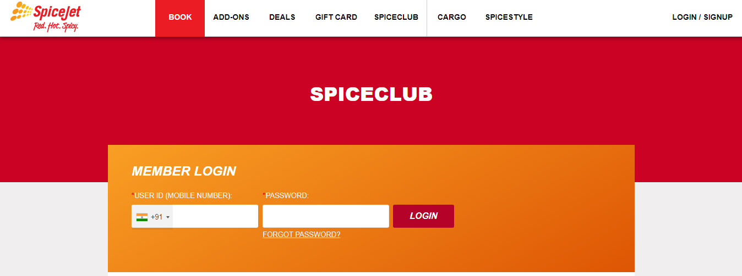

After giving user ID i.e.., mobile number and password clicking on login icon in the above shown figure leads to successful in logging in to the SpiceJet page.

**3.3 Offers:**

Here are the list of red hot deals that a customer or user can afford. In order to avail the deals follow the steps below:

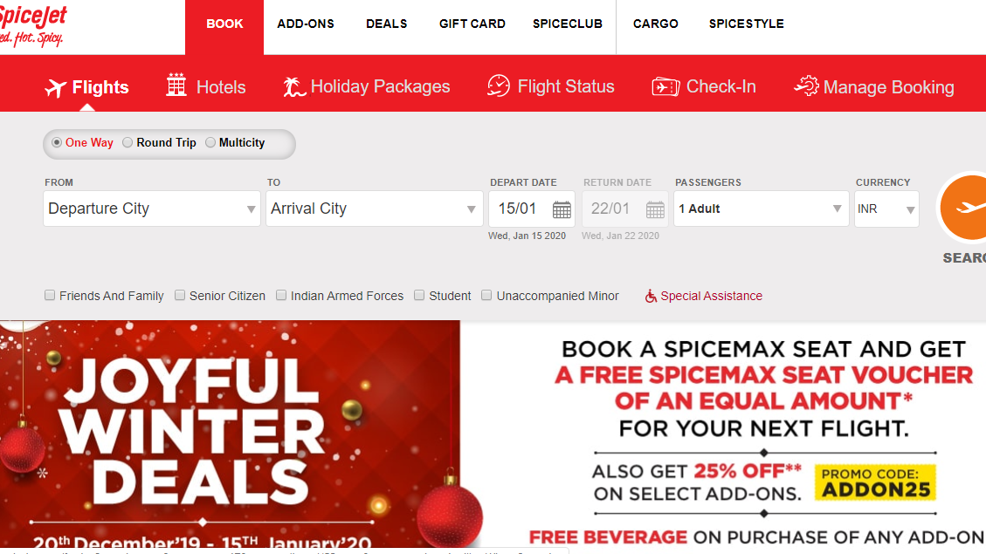

On the home page Click on the deals so that you can be directed to the offers and deals page that are available at that moment.



Users can sort and filter offers based on their interest and requirements from the above categories.

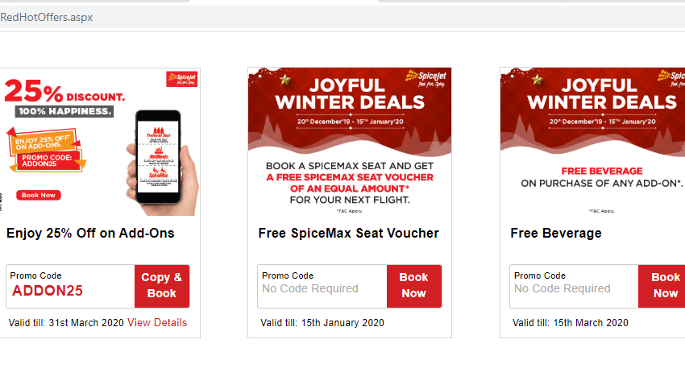Based on the deal the user has selected, each deal will either have a unique promo code, that has to be entered by the user while availing the deal, or no promo code.



And also a user can experience the best location by choosing luxury hotels from the available packages.

**3.4 Book Tickets:**

Book tickets is an option to know the availability of tickets for the travel with respect to FROM and TO of the travel of passenger on a particular date.

Passenger have to enter the departure and arrival cities along with depart date , number of passengers and click “SEARCH”

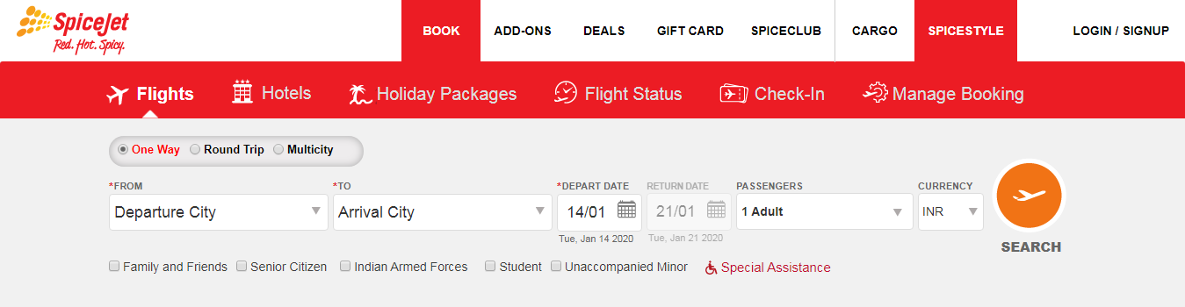

**3.4.1 Choosing a Departure Flight:**

Here, a list of flights for the selected FROM and TO are displayed and passenger have to select one as per their interest. Passenger have to click on “CONTINUE” in order to proceed further upon selecting the flight.

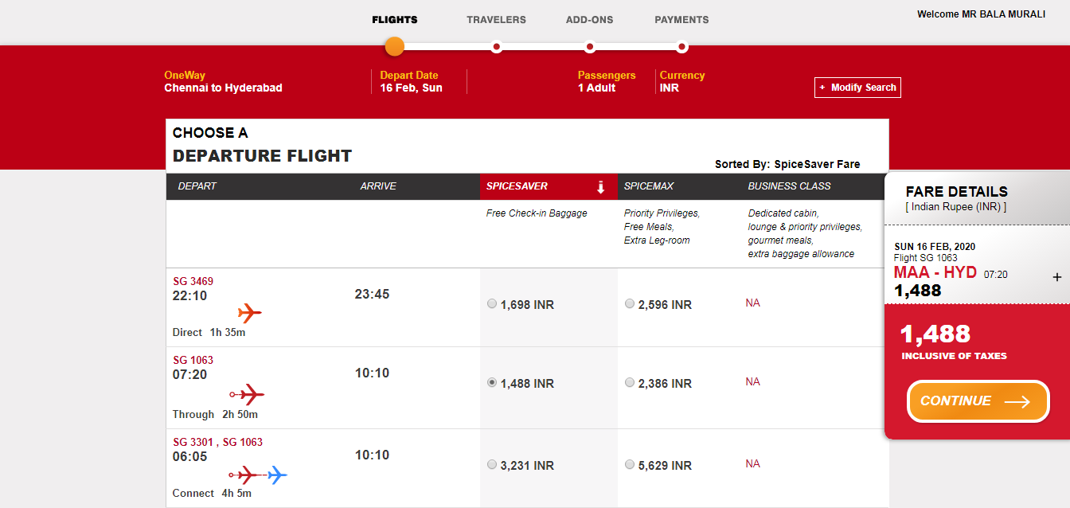

**3.4.2 Traveller Details:**

Passenger have to fill the personal details like name, mobile number, email, country, city etc., required by the SpiceJet team to reserve a ticket. And click on “CONTINUE”

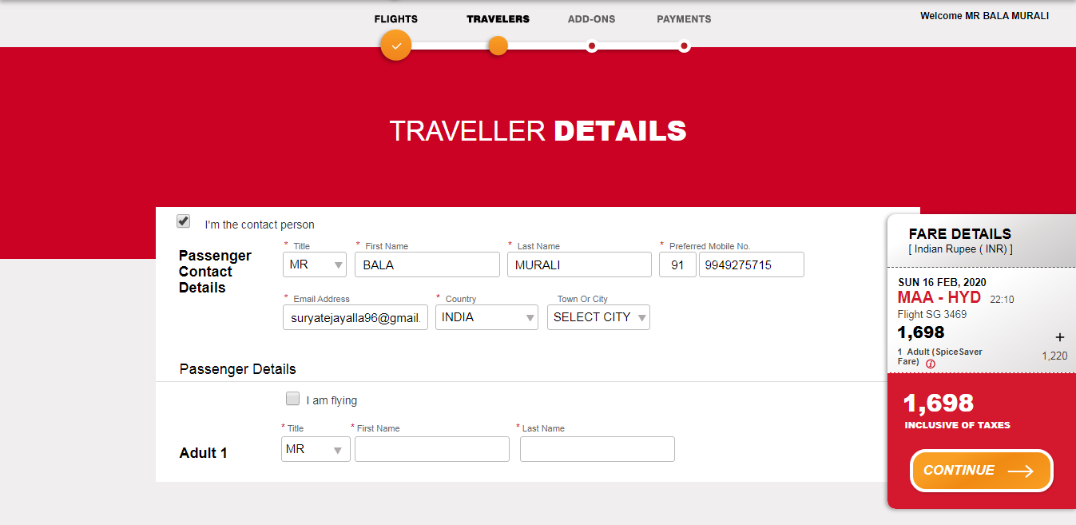

**3.4.3 Add-Ons:**

“Add-Ons” are additional services at extra costs that can be added onto your booking to add convenience onto the passenger’s trip. These extras can include booking meals, extra luggage, priority boarding, airport lounges and travel insurance etc.,

It helps the customize passenger package to suit their needs and comfort.

Here, Passenger have to click “ADD” on the respective deal.

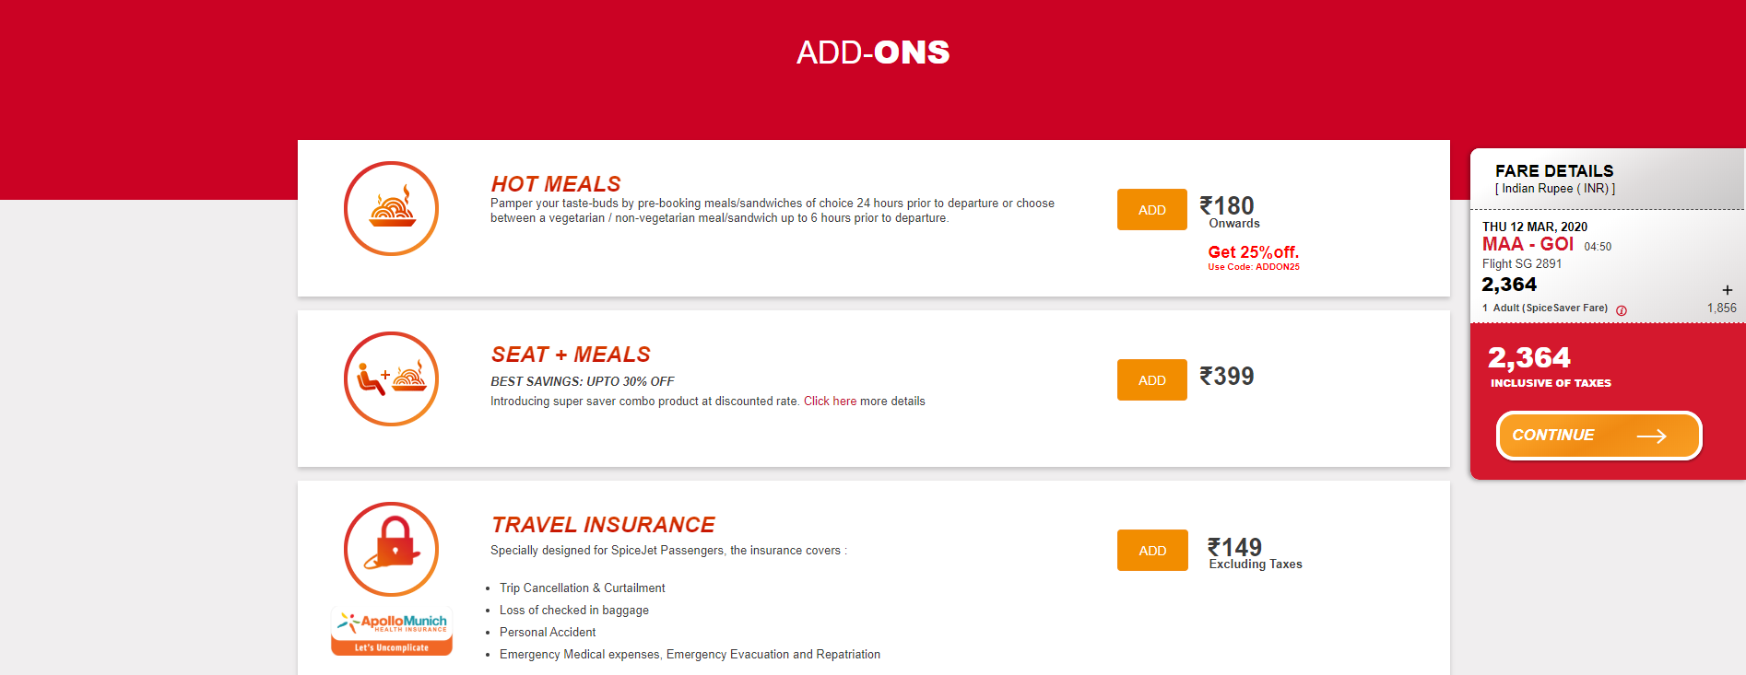

**3.4.4 Seat Assignment:**

Here, each ticket is assigned a specific seat in the flight at the time of purchase. Seats are typically identified by row number/ latter, seat number, and sometimes by section.

Here, passenger has to select their desired seat from the available seats which are shown in yellow fill and click “CONTINUE”

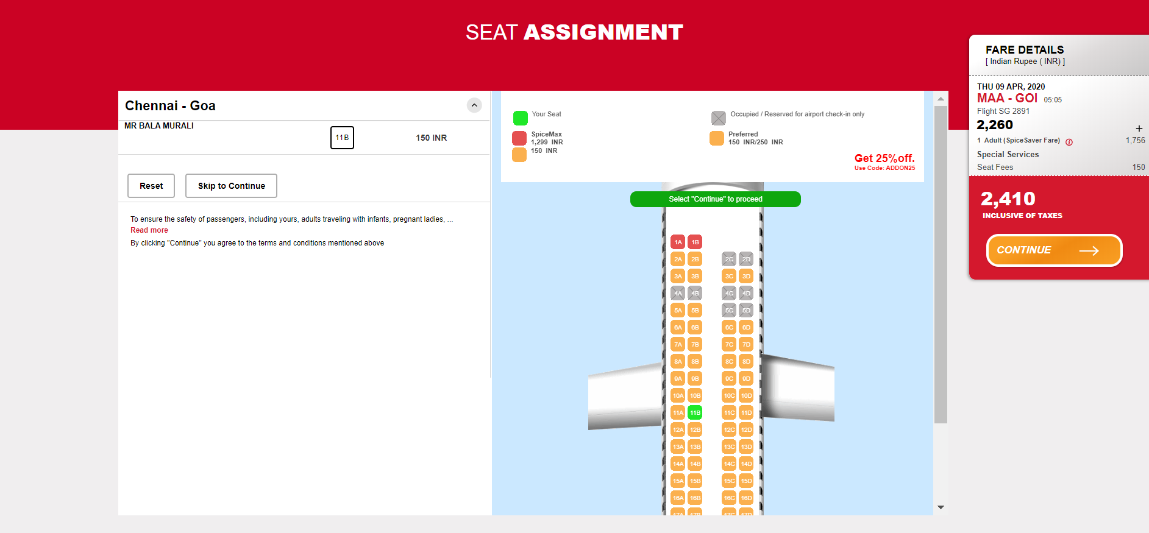

**3.5 Adding Payment Details:**

Here, passenger have to fill the bank credentials like card number, card holder name, valid up to, cvv etc. and click “CONTINUE”

Here, Passenger can use any credit issued by master / Visa / Amex & certain debit cards. Wallet, net banking and Rupay cards are currently accepted for travel within and ex India only.

Amex cards can be currently use for online bookings made for travel originating from India, for domestic travel within India and for travel originating from USA, UK, Europe, Japan and Singapore.

If the payment is successful you will receive an Itinerary receipt by email.

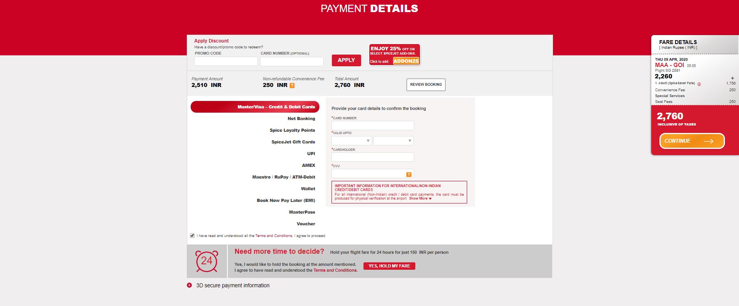

**3.5.1 Payment Confirmation:**

Here, passenger have to enter the one-time password sent to the passenger’s respective given mobile number to confirm the payment.

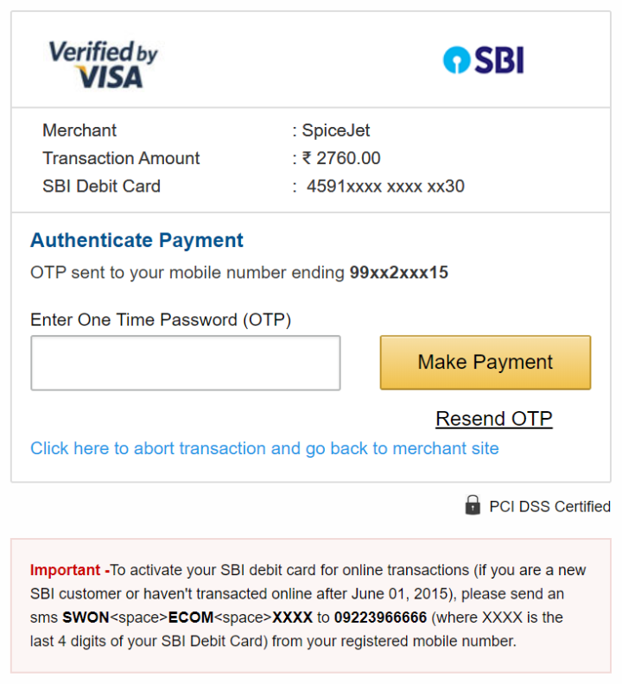

**3.5.2 Confirmation Summary:**

Finally, confirmation summary is displayed. Here passenger can see the booking information, Travel information and Passengers information.

And it ensures that the passenger get a confirmed seat in the desired class of a flight.

Furthermore, as an ease to travellers a unique Passenger Name Record is generated for every ticket that is booked.

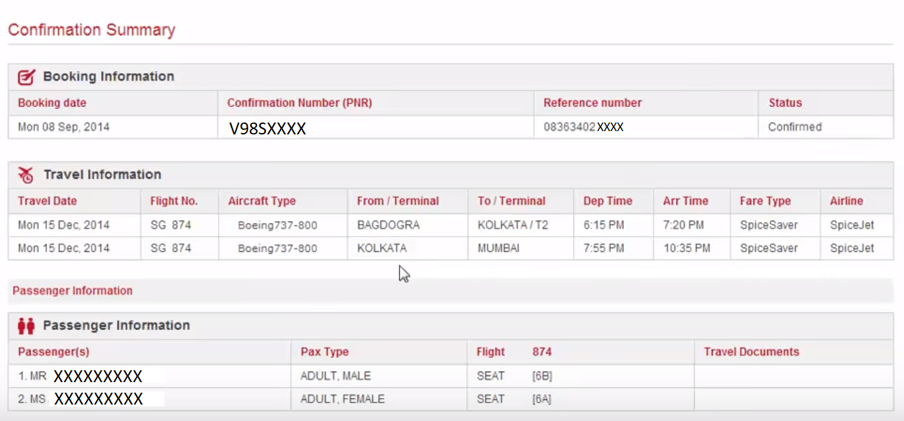

**3.6 SpiceJet Ticket Cancellations:**

In the Homepage of SpiceJet app users click on the change/cancellation icon after that passengers can choose an alternate flight option or cancel the ticket or change date and time of the flight.

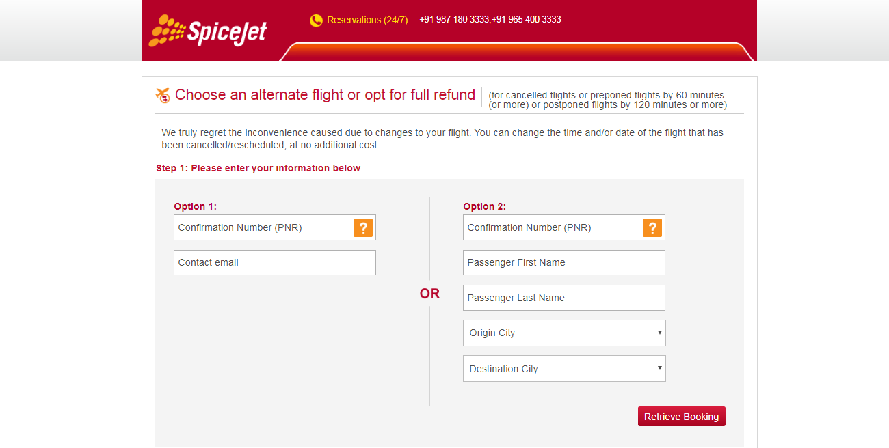

Users can fill the information details in either option 1 or option 2 based on their choice i.e., option 1 fill the confirmation PNR number and contact email. In option 2 fill the confirmation PNR number, passenger first name and last name, origin city and destination city.

SpiceJet ticket cancellation is not possible for the bookings not made through the airlines directly. For making any changes in the travel time or date has to be informed 2 hours prior to the departure of the flight. The tickets are non-transferable. This means that the name on the ticket cannot be changed.

The passengers have to bear the difference in fair on the new date and time. You can call the customer service at 1800 180 3333 for changing the date or time of travel.

SpiceJet ticket cancellation in case of bad weather or any other circumstances that are beyond control is not the liability of the airline. The airline will make all the efforts to get you to your destination.

The airlines has all the rights to cancel the flights or delay them.

**3.7 Log out:**

Here, passenger have to select the “LOGOUT” option, it informs the website that the current user wishes to end the login session.

Logging out helps prevent other users from accessing the passenger account without verifying their credentials.

It also helps protect the current user access or prevent unauthorized actions on the current login session and is thus an important part of security

Logging out ensures that user access and user credentials are safe after the login session.

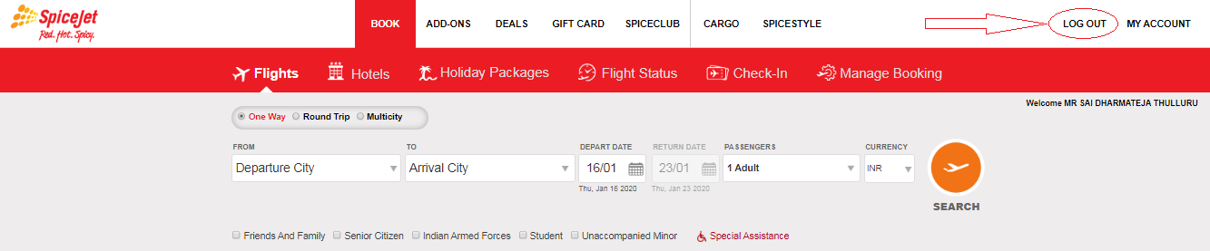

# Sign-Off Document

_____________________________________________________________________________

The following parties have read and agree with this Requirements Definition document for the SpiceJet application account module functionality.

After approval of this Requirements Definition phase, any significant changes in the scope of this project will require validation of existing project costs and schedules.

_______________________________________________________________________

Name Date

Business Lead

______________________________________________________________________

Name Date

Project Manager

**Prepared by: Bala Murali Yalla**